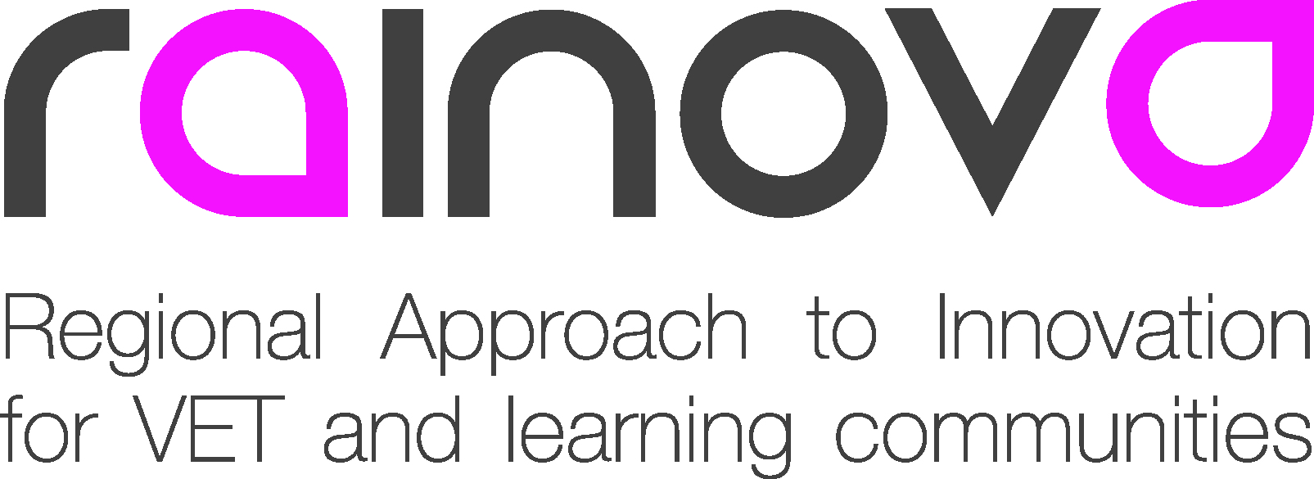 |  |  | 

Project Number: 517752-LLP-1-2011-1-ES-LEONARDO-LNW

Project acronym: Rainova

Project title: Regional Approach to Innovation
for VET and Learning Communities

Deliverable reference number: D.3

Deliverable title: Monitoring and Evaluation Strategy

Due date of deliverable: End of March

Actual submission date: 23rd February 2012

Start date of project: 1 January 2012 Duration: 36 months
Organisation name of lead contractor for this deliverable: PAUL GARVEY Consultancy

Project co-funded by the European Commission within the Lifelong Learning Programme (2012-2014)
Dissemination Level
PU | Public
PP | Restricted to other programme participants (including the EC services)
RE | Restricted to a group specified by the Consortium (including the EC services)
CO | Confidential, only for members of the consortium (including EACEA and Commission Services and project reviewers) | X

Monitoring and Evaluation Strategy

February 23rd 2012
Summary

To measure, assess and help ensure that partners complete the work assigned to them and that the project as a whole meets its objectives.

There is no external evaluation as such as the project work package leader for evaluation is a full partner and not external to the project. However a degree of externality in the role will be offered and a degree of independence will be maintained.

The project monitoring will be a key responsibility of the College Wales partner as well as PGC Ltd and we will work closely together.

Our two organisations have formulated this plan and together will make arrangements for monitoring and evaluation.

It is recommended that the Evaluation and Monitoring co-coordinator team be members of the management group.

Self monitoring and self evaluation

As with dissemination each partner will be responsible for their own local monitoring and evaluation plan.

Partners will be requested to maintain full records of their activities on the templates which we will issue.

We will issue a list of performance indicators that all partners should follow. These performance indicators closely follow those identified in the application and partner contract so that they can be readily checked and measured.

The results should be entered on the website. Hard copies should be provided to the evaluation and monitoring team only as necessary.

Protocol

We propose to identify an agreed protocol of behaviour which will have the support of all partners and will be confirmed at the next transnational meeting in Romania.

This protocol will help facilitate the progress of the project
And provide ground rules for the conduct of the partners.

User focus

Following best practice the end user/small business etc will be the focus of the project and will be at its heart.
It is suggested that a prospective user of the pilot be identified and involved from the outset so that they can influence the formative stages of the service which is being developed.

Feedback and monitoring of pilots etc will be a key outcome of the project.

Six monthly reports

Six monthly short reports will be very specific, delivered verbally and informally and posted as a short report after the respective transnational meeting and the meeting of the Monitoring and Evaluation work group.

Interim Evaluation

The Interim Evaluation will be produced at the half way stage of the project. It will be substantial and will identify all the strengths and Issues that have emerged.

The findings of this report will allow for partners to build on their strengths, complete outstanding tasks and deal with aspects of the project which are not progressing as well as hoped.

Partners have their own responsibilities for their work and collectively for the project as a whole. It will be assumed that all partners are generally clear what there individual tasks are and are confident as to how they will progress through the milestones for delivering them.

Whilst a detailed interim report is considered best practice this is only really effective if partners take note of the conclusions and can subsequently demonstrate that they have acted on the issues raised.

Previous agency reports have commented on the value of an interim report.

The theme for the six monthly reports held after the interim will focus on its recommendations and on the response to them.

(The feedback to the first meeting has been summarised and is attached in an appendix. Please take notice of the comments as they affect your project team and take notice of the messages being given by the project and monitoring team)

This is most important for the partner hosting the next meeting. It would be helpful if all the strengths and ‘even better if’ issues could be adopted for the next meeting.
e.g. first evenings together, ensuring quieter delegates are encouraged to participate etc.

Keeping Records

Partners are requested to keep records that are audit-able and measurable. (SMART)

“Visited a number of training organisations to share the planned benefits of Rainova” for example will not be sufficient.

An activity like this should record the name of the organisation/date/purpose of visit /who visited and the outcome. These should be entered on to the templates provided so that all partners’ returns are consistent.

Evaluation at transnational meetings

Evaluation of every activity and meeting during the transnational meetings will be recorded

These workshop evaluations will be received by the workshop leader and feedback acted on. Evidence that the workshop leader has acted on the feedback where appropriate will be sought.
A meetings pro-forma for this feedback will be brought to the next meeting.

Workshop reports should then be given to the project lead partner in the first instance. Copies will be forwarded to the evaluation team before the end of the three day meeting for later analysis.

Each work package leader will have a responsibility to ensure that all the partners in their work group complete the forms after each activity. Each partner should ensure that they are completed. There is no reason why there should not be a 100% return on workshop evaluations.

Partners are requested to keep accounts of the following and to bring the results to the meetings. There isn't the resource to undertake forensic research! They will be discussed in the round at the work package meeting.

Performance indicators will include:

- The maintenance of records showing expenditure against budget and timely returns (a key issue for the project leaders)

- Achievement of work plans to target
- Attendance at meetings
- Comparisons of progress between partners
- The extent and effectiveness of partner communication methods
- Partnership working generally both bi-laterally and in groups
- Added transnational value
- Use of website and platform
- Dissemination activities

There may be performance indicators that are particular to individual partners and not on this list. They should be discussed separately with the evaluation team.

- Ongoing assessment of the marketability of the results
- Exit strategy

Progress Reports

A Progress Report from each partner for the previous six months should be submitted to the evaluator and discussed in workshop meeting where time allows. The report should focus on achievement against milestones and any identify any barriers to success and how it is proposed that these barriers are overcome.

Monitoring methodologies and techniques will include:

- Interviews
- Focus groups
- Pro formas
- User discussions
- One to one meetings
- Partner meetings
- Reports
- Website/platform use
- Self evaluation systems
- Information from users
- Pilots
- Observation
- Participant observation
- Eyes and ears
- Evaluation meetings with Sian, Judy and Paul

Action planning to deal with underperformance

Monitoring of key issues that may undermine the success of the project will be ongoing.
Addressing these issues will be the responsibility of the lead partner and evaluator who will address any concerns together and agree a solution

Threats and major concerns would include:

- Partner relationship breakdown/loss of trust
- In house lack of support
- Failure to meet deadlines
- Failure to meet financial report deadlines with consequent lose or delay of funds
- A poor interim report from National Agency/Unsatisfactory report from Commission auditor

Paul Garvey/Sian Holleran

